**CONVOLUTIONAL NEURAL NETWORKS:**

Computer vision is useful for image classification,object detection etc

For 1000*1000 image of RGB x would be 3M dimensional and if first layer have 1000 units

W1 would have 3B parameters which is computationally and memory wise intensive and would need a lot of data hence cnn are useful

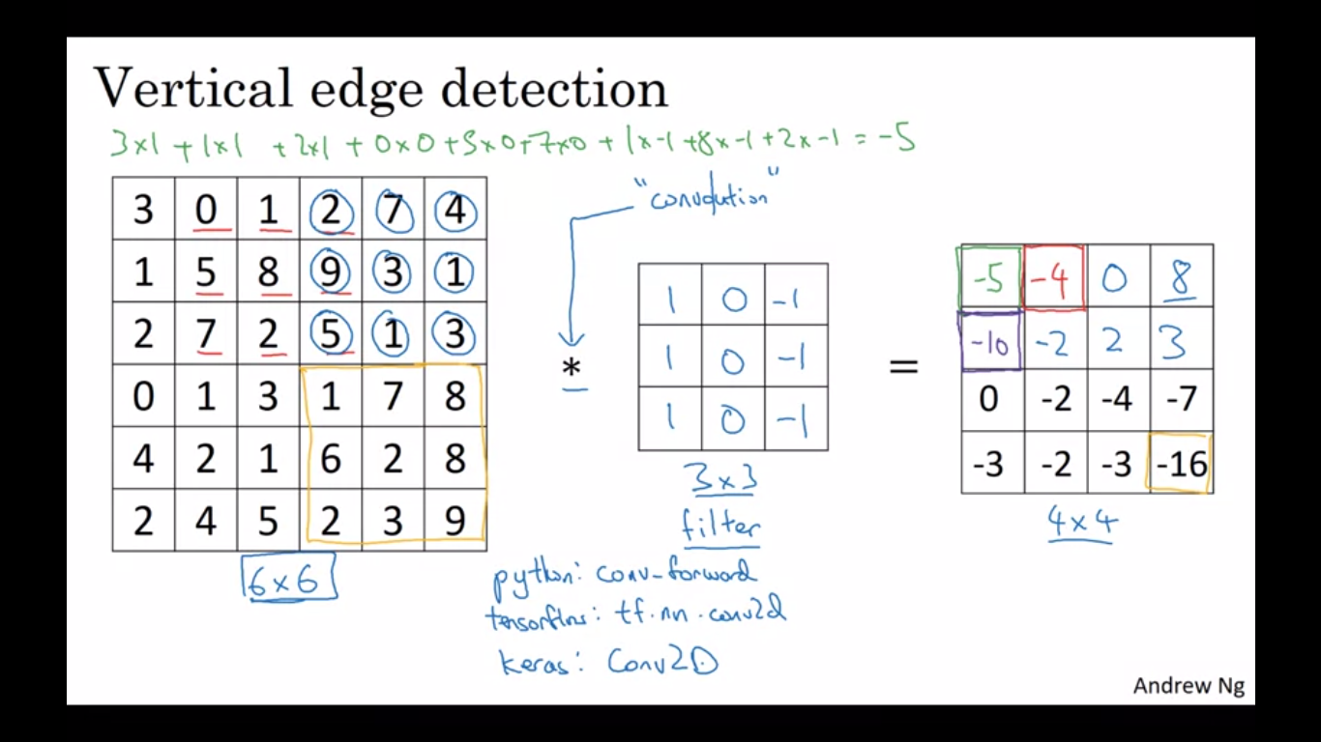

For **edge detection**(early processing of image),we convolute our image with a **FILTER/KERNEL,**which consists of weights multiplied by different parts of image and their sum is stored in final image,the output will give bright color for edge

Bright portion indicates positive edge(white to black) and dark portion indicates negative edge(black to white)

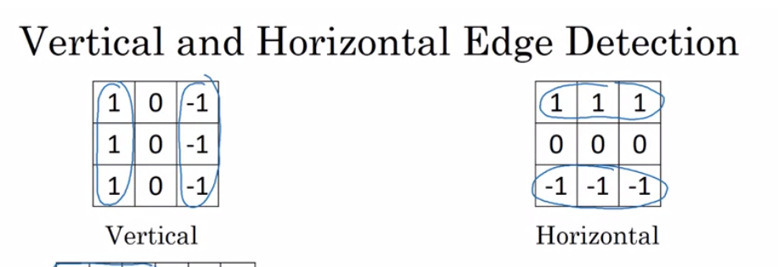

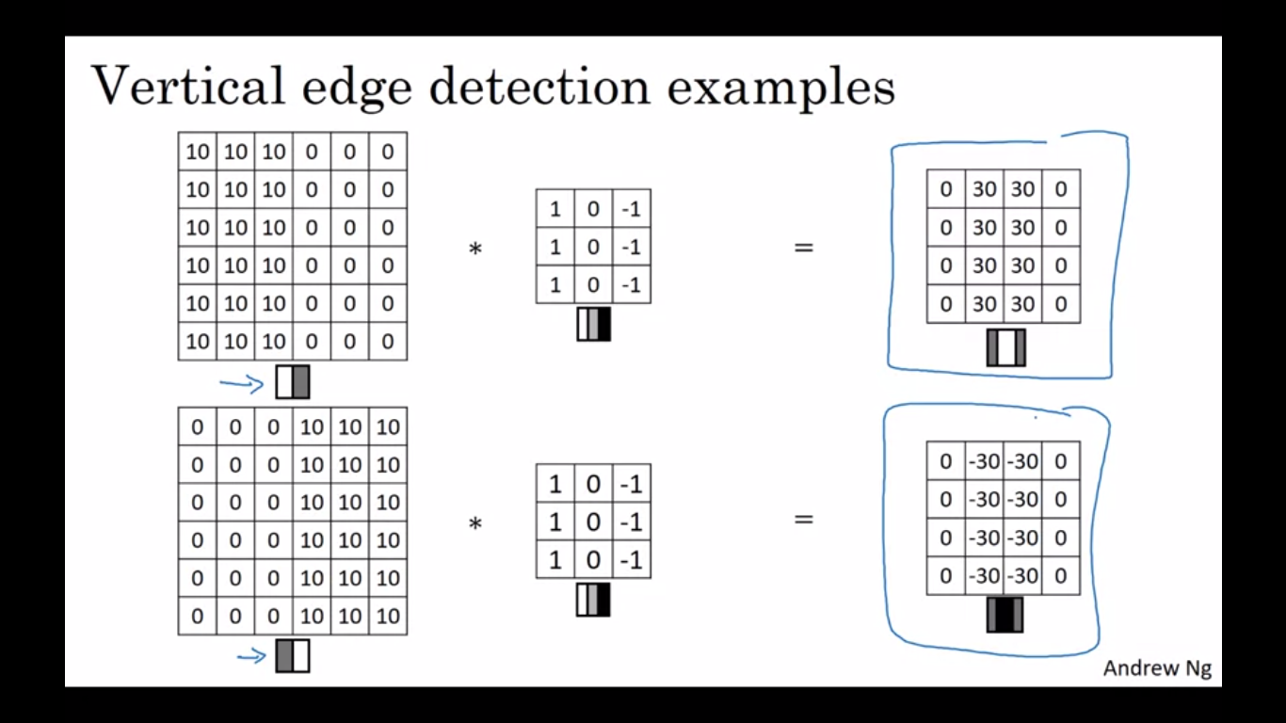

Rather than setting values of filter by hand, we can use them as parameters which our NN will learn and build a better edge detector also detecting angles other than horizontal and vertical

**PADDING** : 1)avoid shrinking image 2)avoids lost of information from edges as they are less involved

**VALID CONVOLUTIONS:** no padding,input used as it is

**SAME CONVOLUTIONS:** Pad so that input matrix is as it is after convolution(p=(f-1)/2)

p=layers of padding layers added on each size,f:dim of filter

P should be odd for same convolution and having a center term in filter matrix

**Stride convolutions** is another piece of the basic building block of convolutions as using convolution neural networks.

We're going to step it over by n steps. We're going to make it hop over n steps like so and not transverse through input linearly

If we don't get integer for formula for output blocks,we round it off to nearest integer

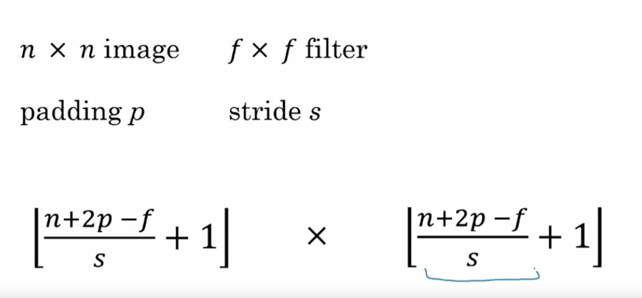

For rgb images,input and filter have 3 channels but output have only one channel

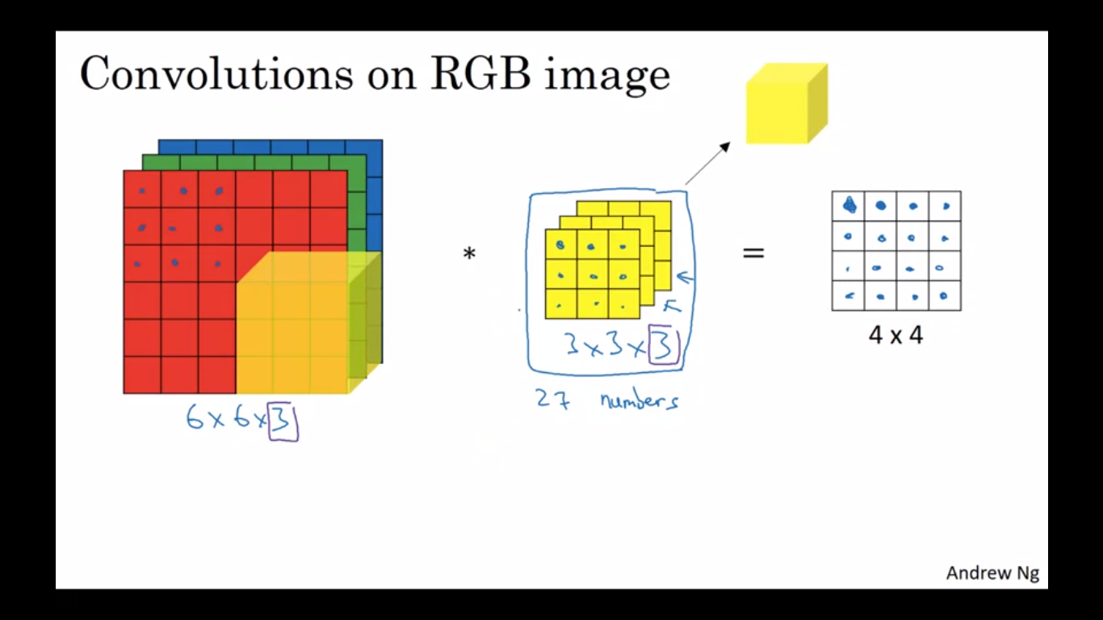

For applying multiple filters to any input,no of channels for output is equal to number of filters

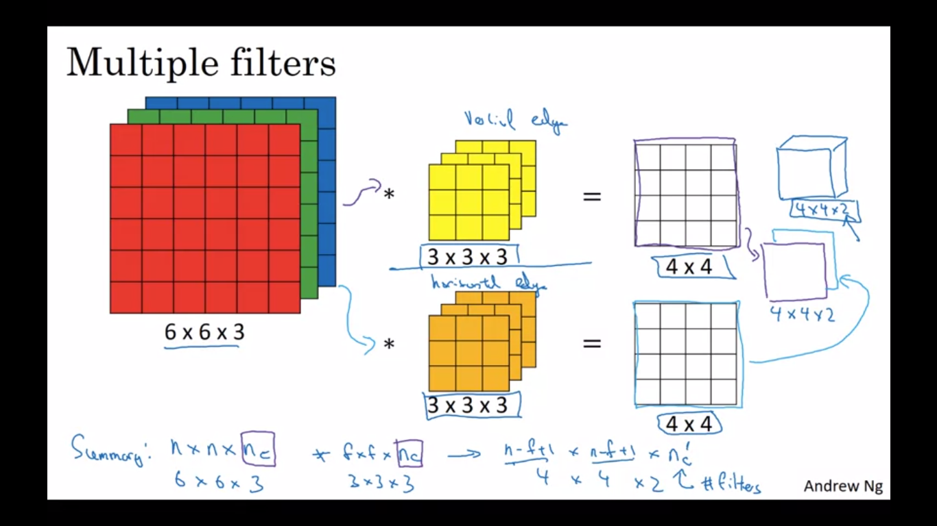

*Advantage of convolution is that if size of input changes,number of parameters remains the same*

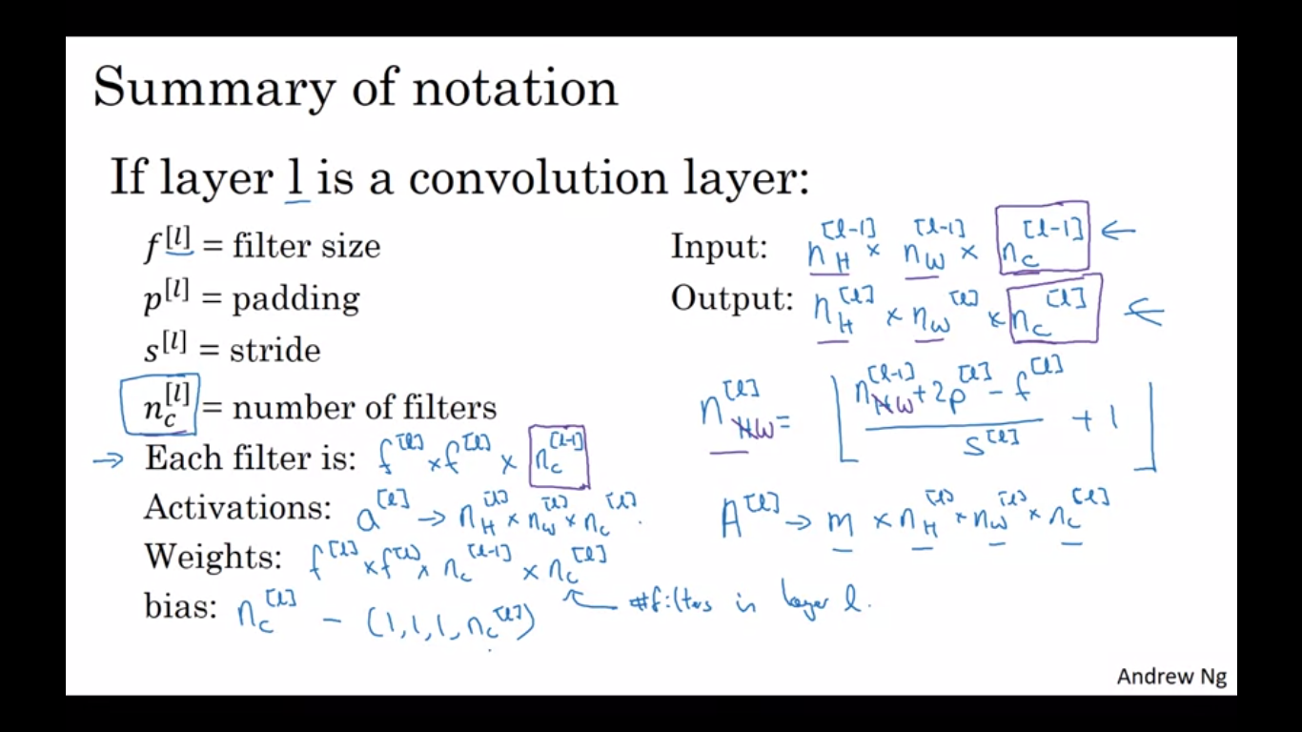

**POOLING LAYERS:MAX POOLING** max element of a block is selected in the output

hyperparameters are mixed, wont be learned by gradient descent(commonly f=2/3,s=2 p=0)

For multi layer input,same operation is applied to each layer independently and all layers are preserved in output

**AVERAGE POOLING** avg of all el is taken instead of max

When we implement back prop, you find that there are no parameters that backdrop will adapt through max pooling or learn. Instead, there are just these hyperparameters that you set once, maybe set ones by hand or set using cross-validation. And then beyond that, you are done. Its just a fixed function that the neural network computes in one of the layers, and there is actually nothing to learn. It's just a fixed function.

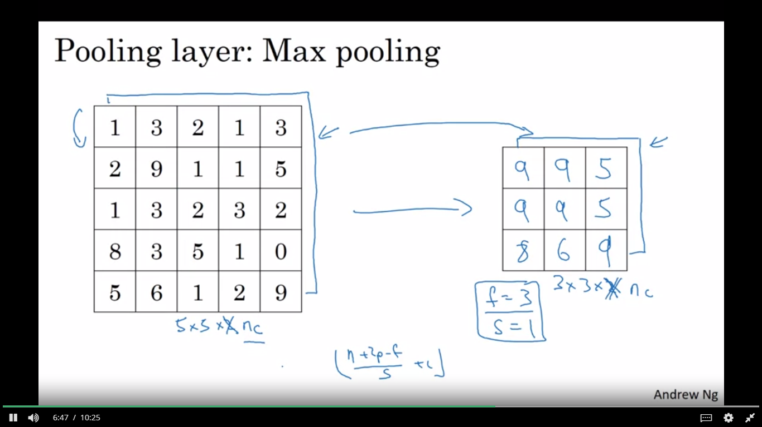

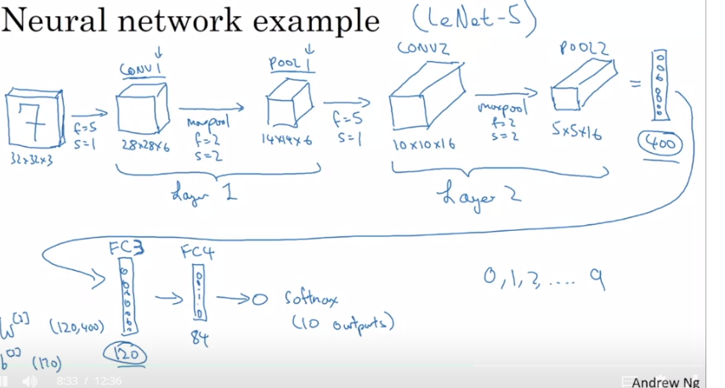

**FC(FULLY CONNECTED LAYERS)**: normal NN layers each node of one layer connected to each node of next layer

Why are CNN better:

**PARAMETER SHARING:**Feature detector such as vertical edge detector, that's useful in one part of the image is probably useful in another part of the image

Same set of features are used for various parts of image

**SCARCITY OF CONNECTIONS:**In each layer each output value depends only on a small number of inputs,not all

**TRANSLATIONAL INVARIANCE:**Shifting pixel positions parallelly wont affect as same feature detector is applied to all parts of image

* A convolution extracts features from an input image by taking the dot product between the input data and a 3D array of weights (the filter).
* The 2D output of the convolution is called the feature map
* A convolution layer is where the filter slides over the image and computes the dot product
  + This transforms the input volume into an output volume of different size
* Zero padding helps keep more information at the image borders, and is helpful for building deeper networks, because you can build a CONV layer without shrinking the height and width of the volumes
* Pooling layers gradually reduce the height and width of the input by sliding a 2D window over each specified region, then summarizing the features in that region

**BACK PROPAGATION:**

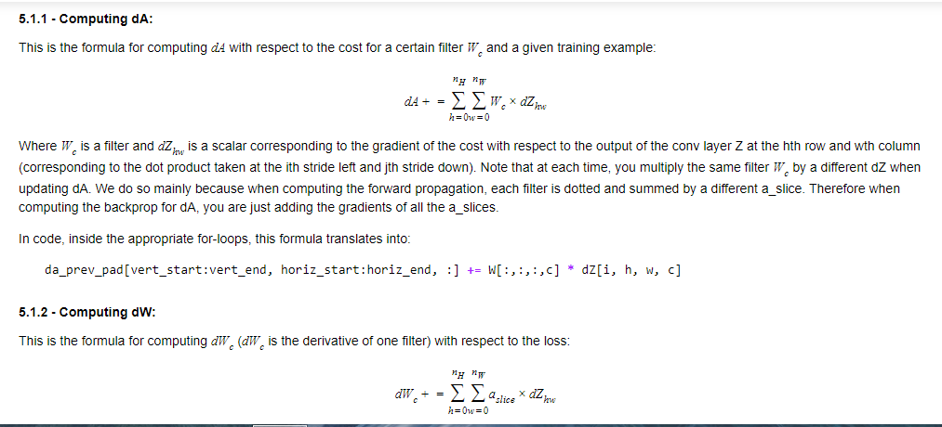

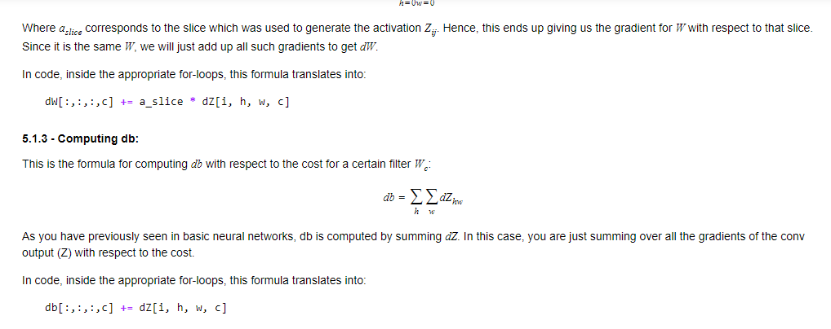

**TENSORFLOW CNN MODEL:**

In TF Keras, you don't have to write code directly to create layers. Rather, TF Keras has pre-defined layers you can use.When you create a layer in TF Keras, you are creating a function that takes some input and transforms it into an output you can reuse later. Keras is a high-level abstraction built on top of TensorFlow, which allows for even more simplified and optimized model creation and training.

TF Keras' Sequential API allows you to build layer by layer, and is ideal for building models where each layer has **exactly one** input tensor and **one** output tensor.

Sequential API is simple and straightforward, but is only appropriate for simpler, more straightforward tasks

The **Functional API** can handle models with non-linear topology, shared layers, as well as layers with multiple inputs or outputs. Imagine that, where the Sequential API requires the model to move in a linear fashion through its layers, the Functional API allows much more flexibility. Where Sequential is a straight line, a Functional model is a graph, where the nodes of the layers can connect in many more ways than one.. In the Functional API, you create a graph of layers. This is what allows such great flexibility.

**WEEK 2**

**LENET-5(1998):** used grayscale images,relu wasnt used as that time so the model used sigmoid and tanh.Different filters were applied to different channels of input as computational power was less then

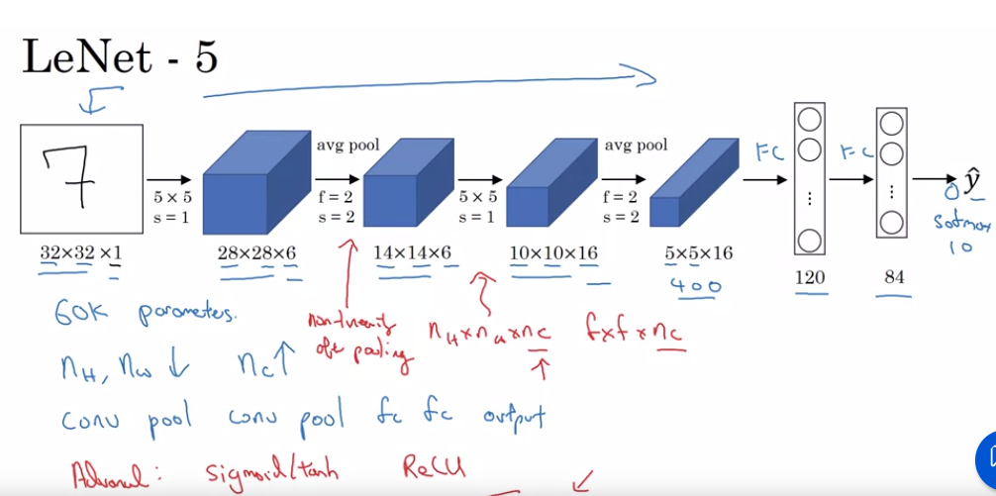

**ALEXNET(2012):** introduced deep learning to computer vision,had lot of hyperparameters,trained on 2 GPUs,layers split among GPUs and communicate,complicated architecture,used RELU,1000 image classes classifier

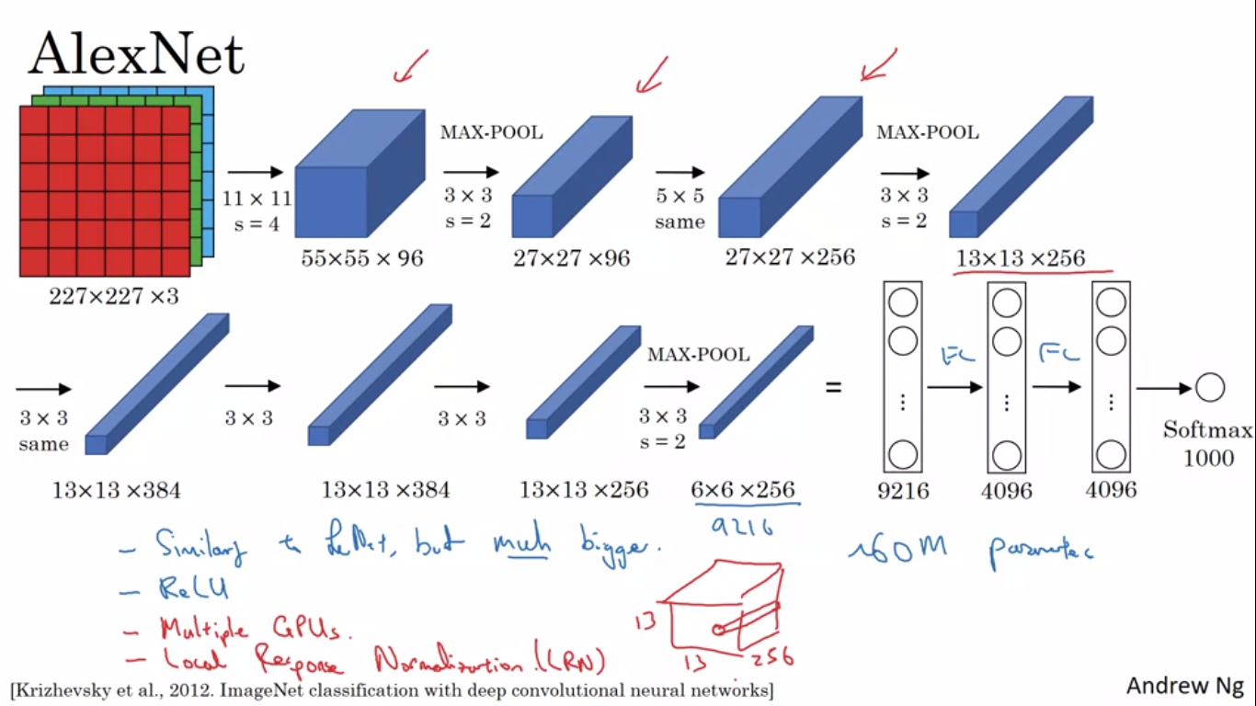

**VGG(2015)**: 16 layers with parameters,fixed size of filter/pool, reduce hyperparameters, approx 138M parameters,number of filter doubles and size reduces to half after each set of layers

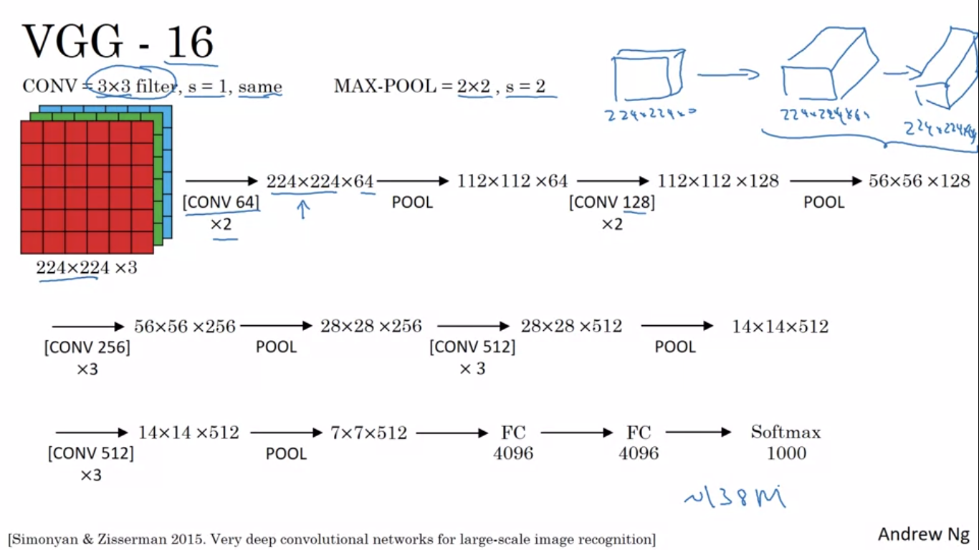

**RESNETS:** reduces vanishing/exploding gradients by skipping few connections in NN(skip connections),helps in training very deep NN.

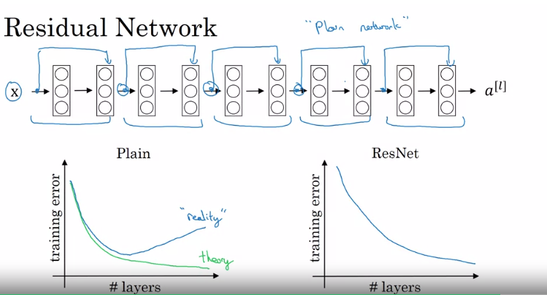

**Plain NN** performance decreases with deep NN as they face difficulty in learning identity functions(a[l+!]=a[l]) but with help of resnet,learning identity fn becomes simpler

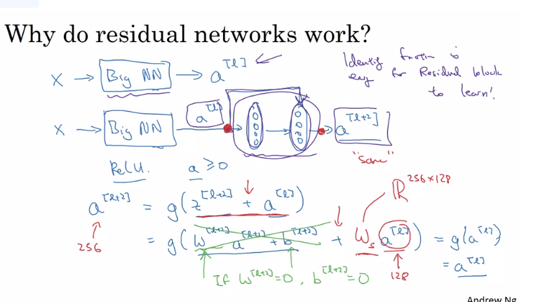

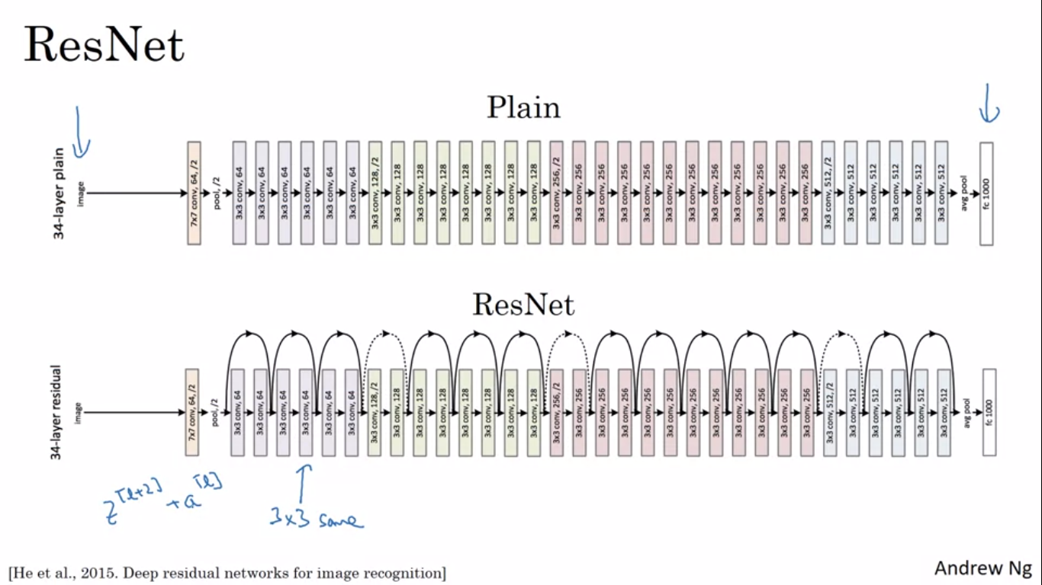

**1X1/NETWORK IN NETWORK CONVOLUTION:** A single weight is multiplied to all channels and their sum is passed on to output.Pooling is used to shrink nh an hw, **1x1 layer can be used to shrink number of channels nc**,adds non linearity.

**INCEPTION MODULE**  instead choosing what filter size you want in a Conv layer, or even do you want a convolutional layer or a pooling layer? Let's do them all.

For max pool to have same size for staking,we will use padding after pooling

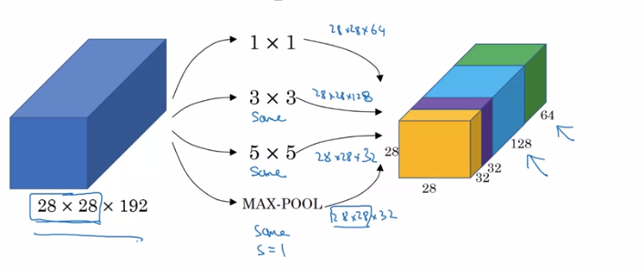

If if we apply 5x5 layer total computations will be 28x28x32x5x5x128= 120M

So to reduce these 10 times, we use 1x1 conv 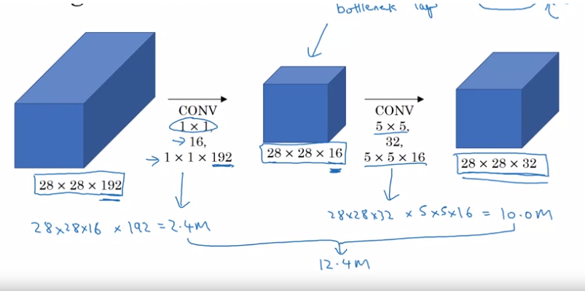

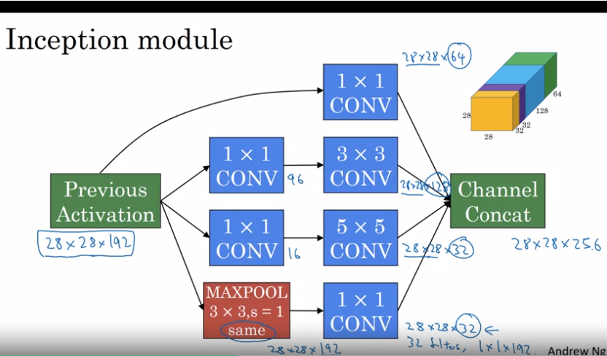

In an inception network,many such inception modules are placed in series and the softmax output is found in few hidden layers for regularization and checking

**MOBILENET:** depthwise separation conv is used where high computation cant be done, number of computations is reduced as each filter is multiplied to only a single channel and nc channels are there is W(depthwise conv).Later 1x1 conv is used to be desired number of channels(pointwise conv)

Here for normal 2160 and for mobilenet,672 computations will be required

For nc like 512,number is reduced upto 10 times

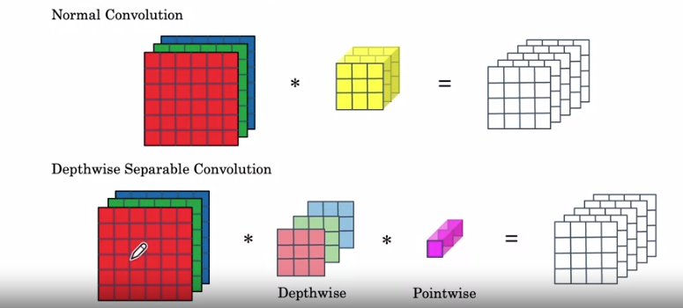

One, by using the expansion operation, it increases the size of the representation within the bottleneck block. This allows the neural network to learn a richer function. There's just more computation over here. But when deploying on a mobile device, on edge device, you will often have heavy memory constraints. The bottleneck block uses the pointwise convolution or the projection operation in order to project it back down to a smaller set of values, so that when you pass this the next block, the amount of memory needed to store these values is reduced back down

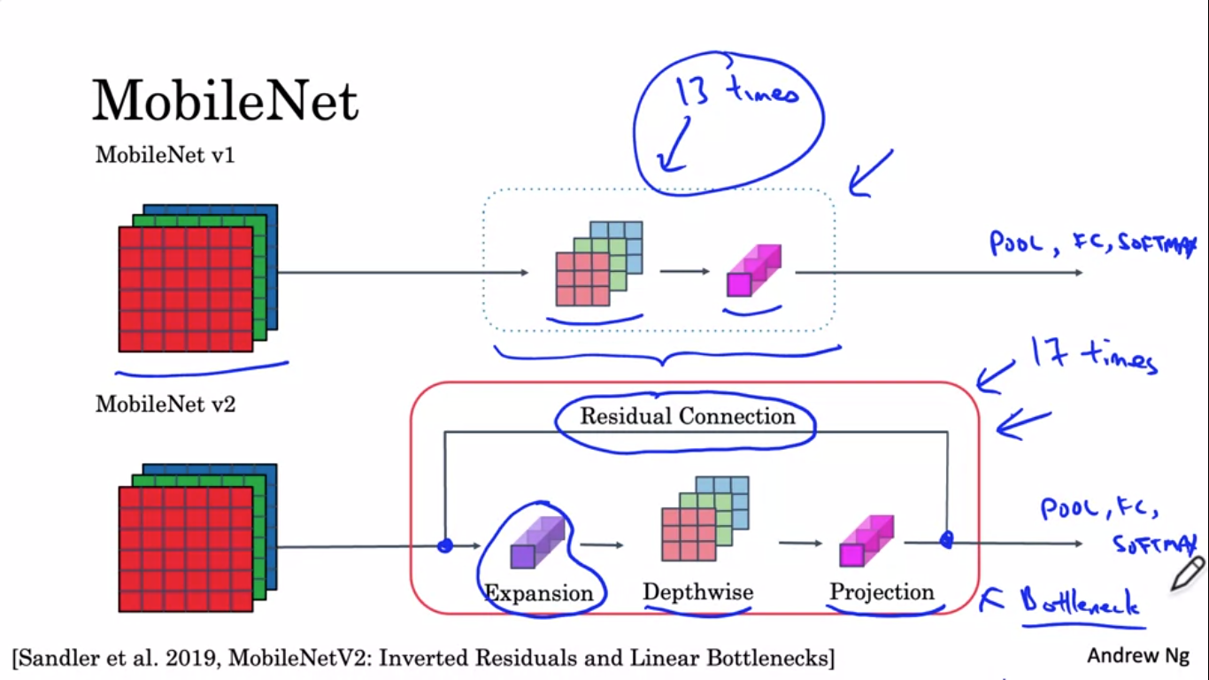

**EFFICIENT NETS:** for specific application and processing resource,resolution of image(r),depth of network(L) and width(number of hidden values) can be adjusted. look at one of the open source implementations of EfficientNet, which will help you to choose a good trade-off between r, d, and w

*RATHER THAN IMPLEMENTING ARCHITECTURES FROM SCRATCH WE MUST CONSIDER CLONING SOMEONES ALREADY IMPLEMENTED MODELS FROM GITHUB AND USING IT*

*After reading paper also it is difficult to work with hyperparameters*

**TRANSFER LEARNING:** using already trained weights on a large dataset and multiple GPUs rathers than training our model from scratch.The bigger dataset you have,more the no of layers you can train else only change the final layer to get desired output.we can save the features calculated of the fixed layers to disk and use them for softmax rather than recomputing them in each epoch

The computer vision research community has been pretty good at posting lots of data sets on the Internet so if you hear of things like Image Net, or MS COCO, or Pascal types of data sets, these are the names of different data sets that people have post online and a lot of computer researchers have trained their algorithms on.

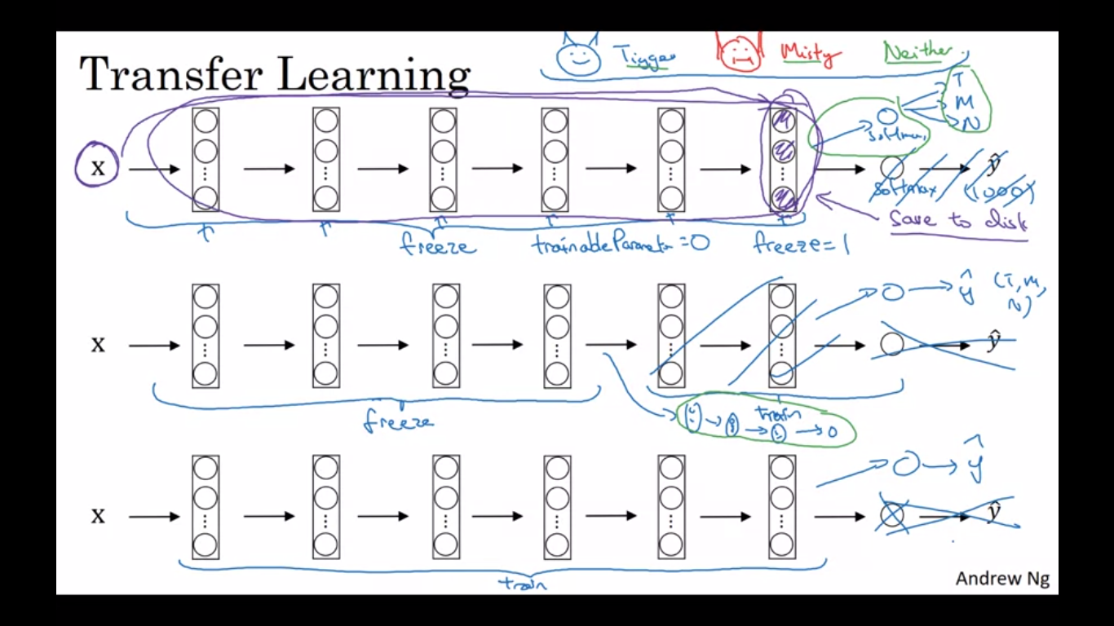

In **COMPUTER VISION** data is never enough so data augmentation is very important

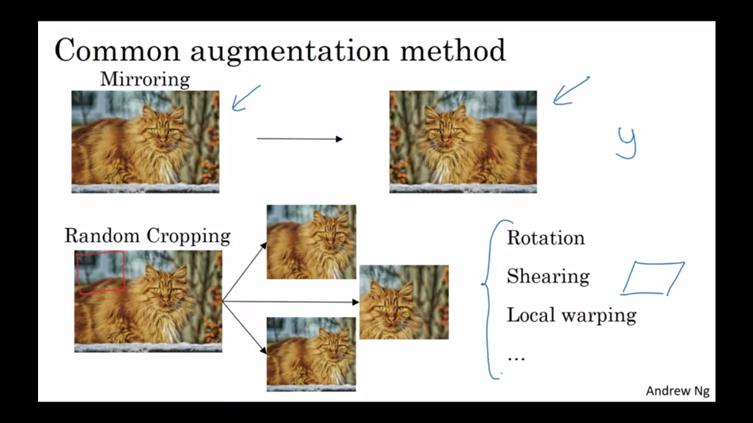

**COLOR SHIFTING:**  the motivation for this is that if maybe the sunlight was a bit yellow or maybe the in-goal illumination was a bit more yellow, that could easily change the color of an image, but the identity of the cat or the identity of the content, the label y, just still stay the same. And so introducing these color distortions or by doing color shifting, this makes your learning algorithm more robust to changes in the colors of your images.**PCA** is if the imag is more purple changing R and B more and G less to keep the colours almost same

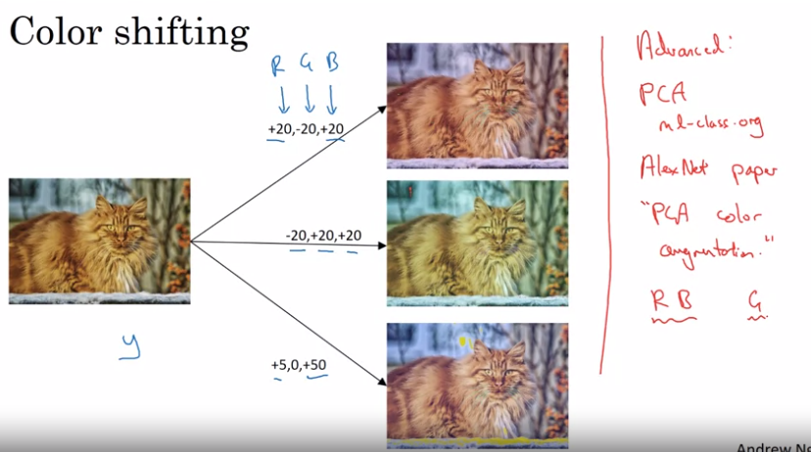

**IMPLEMENTING DISTORTIONS:** when data is in harddisk some threat of CPU can be used for loading data and distorting it(mirroring/shifting etc) and then another part of CPU/GPU will do the training and these 2 will work in parallel

In ML,amount of data increases as object detection(OD),image recognition(IR),speech recognition

For more data, simpler algorithms,less hand engineering is required as NN can learn more

But for CV,data is never enough,for IR data is more than OD as labeling data as yes/no is easier than bounding boxes around objects,so for them more hand engineering,transfer learning is required

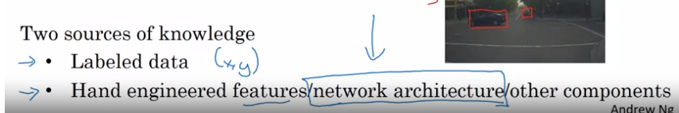

(**NOT FOR PRODUCTION/CUSTOMER USE)**

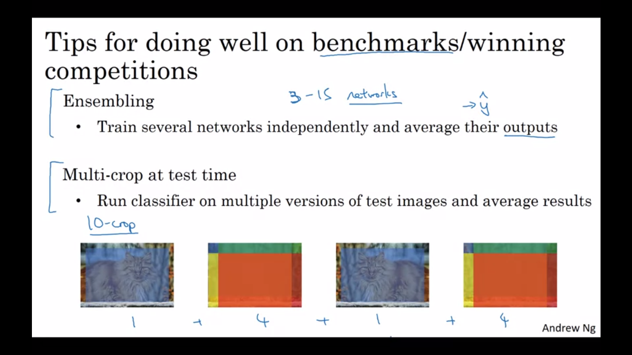

* When calling image_data_set_from_directory(), specify the train/val subsets and match the seeds to prevent overlap
* Use prefetch() to prevent memory bottlenecks when reading from disk
* Give your model more to learn from with simple data augmentations like rotation and flipping.
* When using a pretrained model, it's best to reuse the weights it was trained on.

MobileNetV2 uses depthwise separable convolutions as efficient building blocks. Traditional convolutions are often very resource-intensive, and depthwise separable convolutions are able to reduce the number of trainable parameters and operations and also speed up convolutions in two steps:

1. The first step calculates an intermediate result by convolving on each of the channels independently. This is the depthwise convolution.
2. In the second step, another convolution merges the outputs of the previous step into one. This gets a single result from a single feature at a time, and then is applied to all the filters in the output layer. This is the pointwise convolution, or: **Shape of the depthwise convolution X Number of filters.**

**To adapt the classifier to new data: Delete the top layer, add a new classification layer, and train only on that layer.When freezing layers, avoid keeping track of statistics (like in the batch normalization layer).Fine-tune the final layers of your model to capture high-level details near the end of the network and potentially improve accuracy**